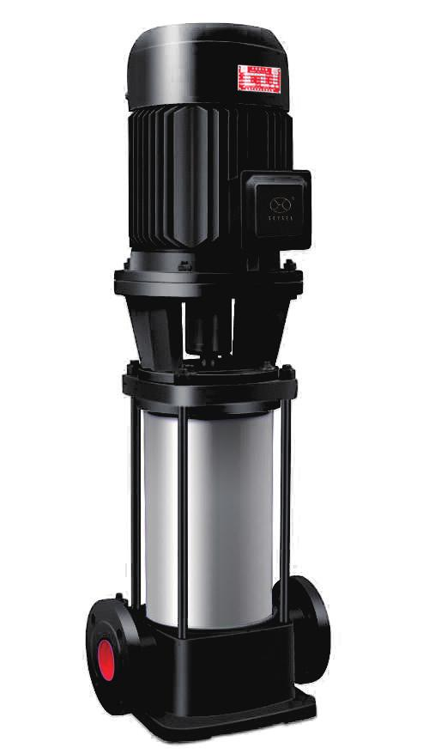
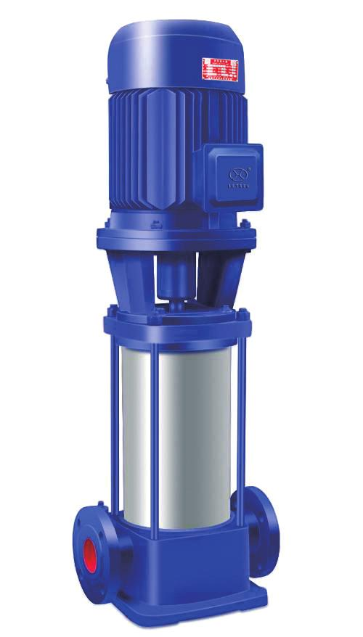

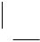



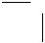
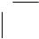
GDL 立式管道多级离心泵
GDL v er tical p i pel ine mul ti stage
centrifugal pump

www.skyse a.com.c n
263

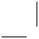
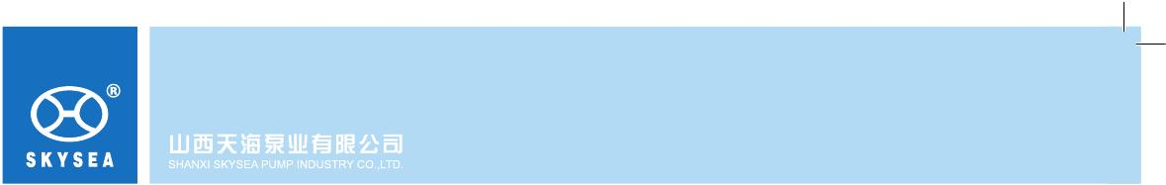
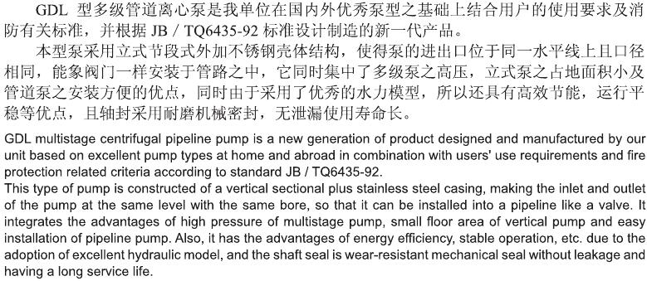
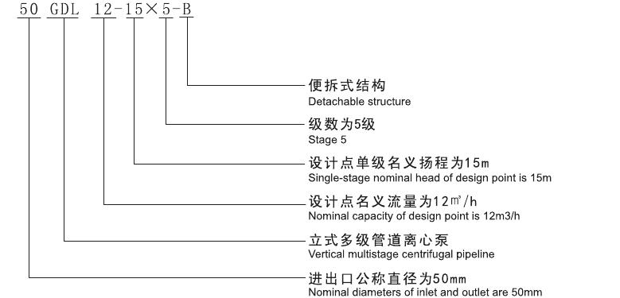
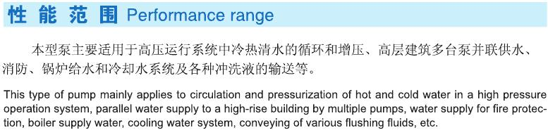


Type
流 量 Q
Fl ow
Head
Efficiency
Sp eed
Power
Sh aft power Motor power
NPSH
Inlet and outlet
diameters
H eight
Wei ght
Hei ght

264

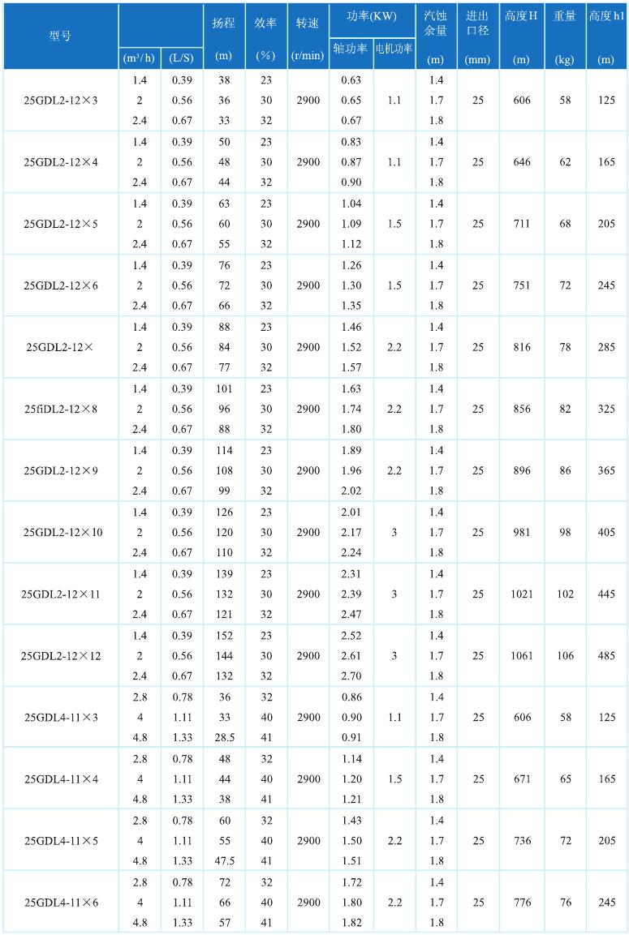

Type
流 量 Q
Flow
Head
Efficiency
Speed
Power
Shaft power Motor power
NPSH
Inlet and outlet
di meters
Height
Weight
Height

www.skyse a.com.c n
265


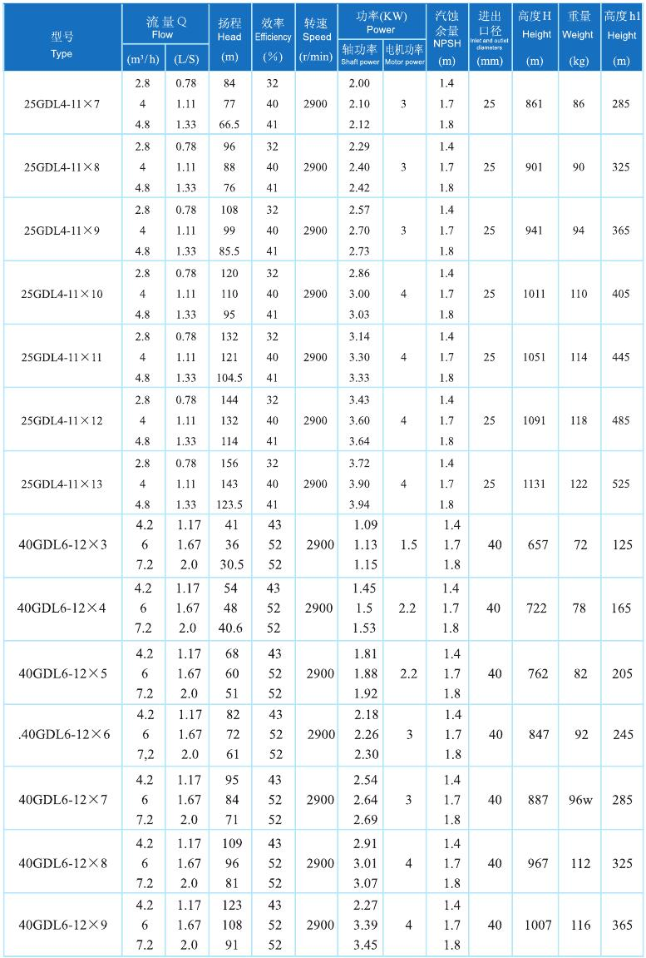

266

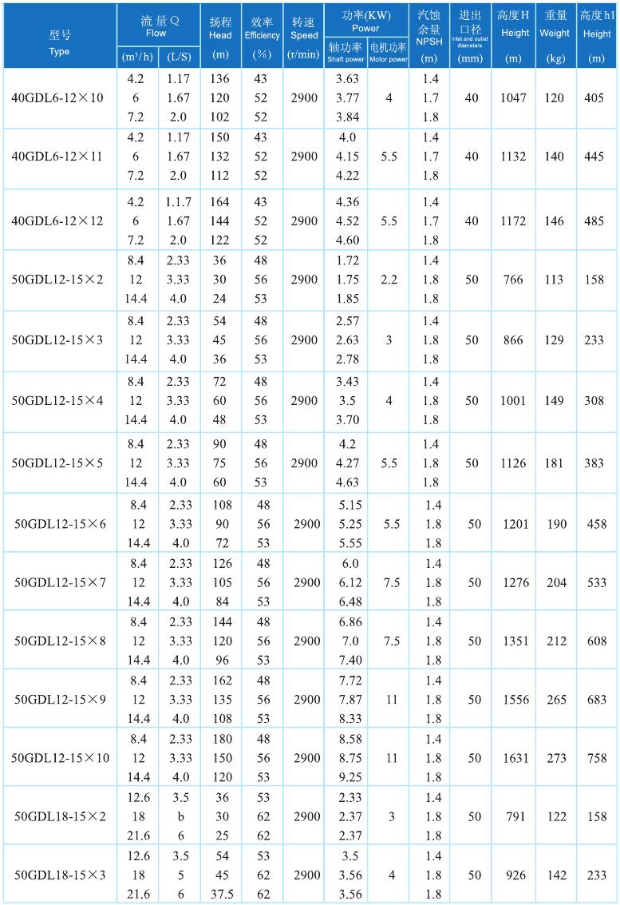


www.skyse a.com.c n
267

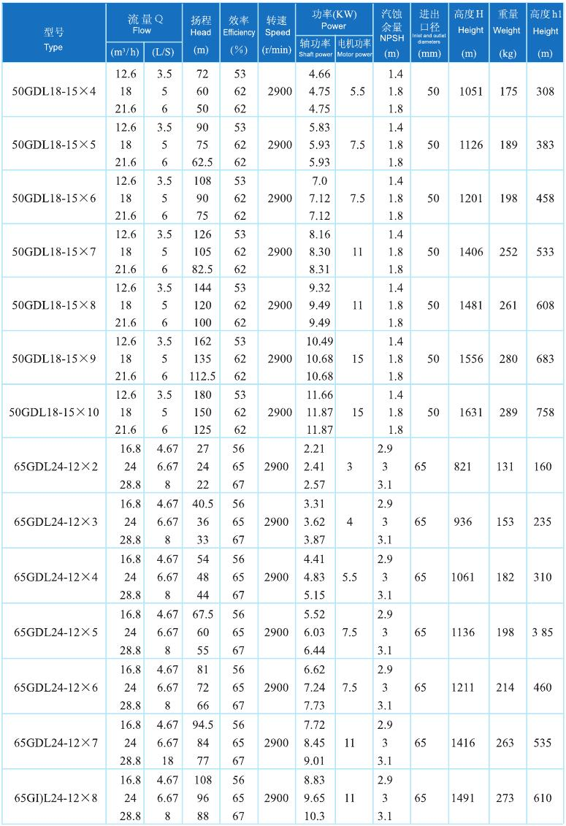

268

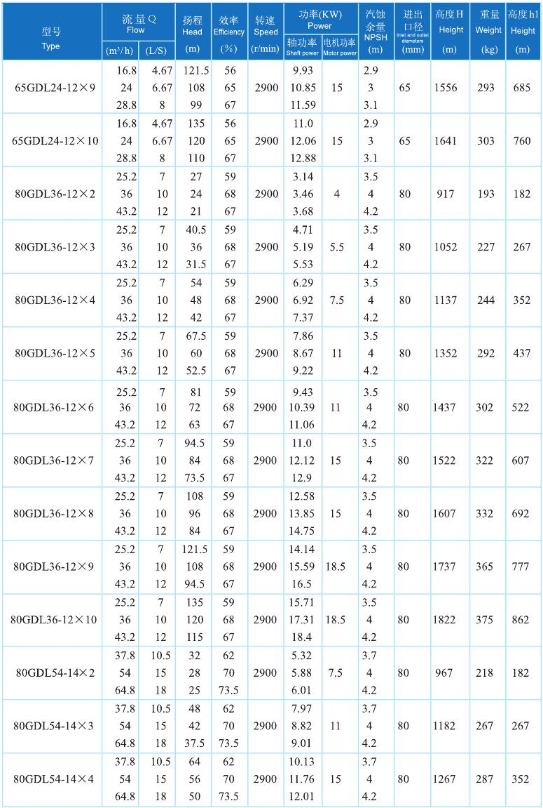

www.skyse a.com.c n
269

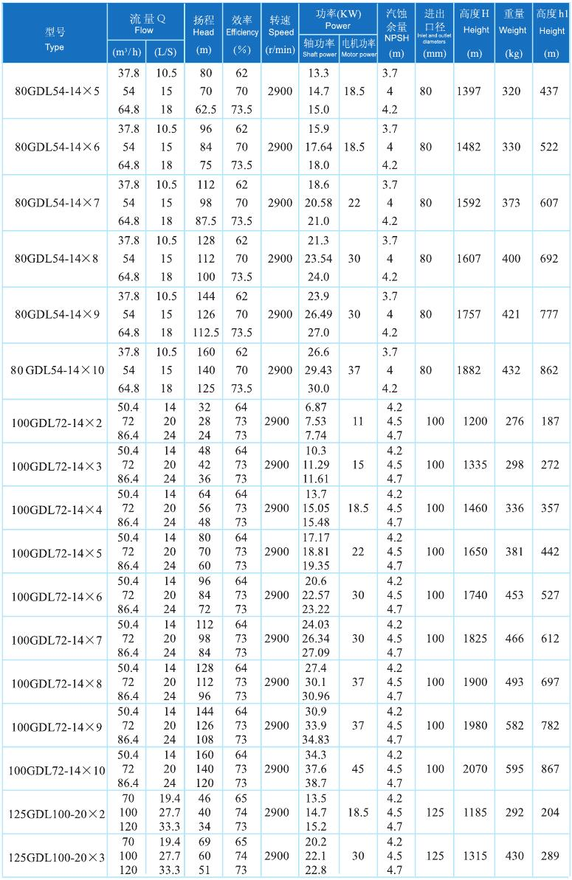

270

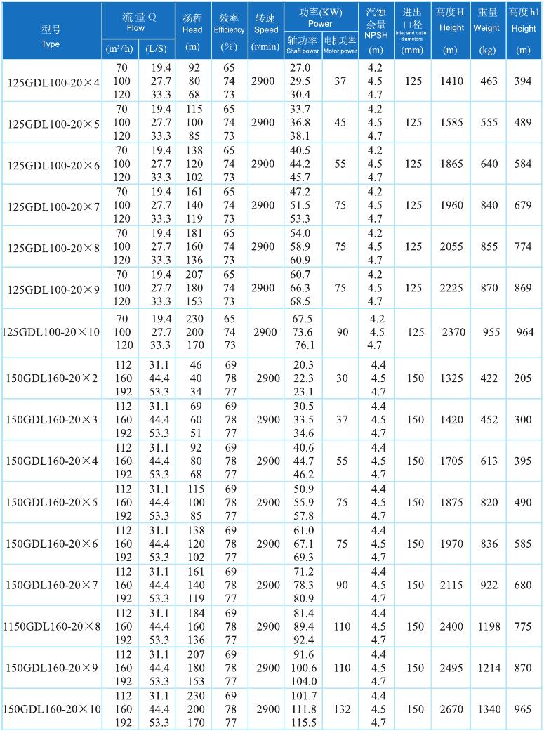

www.skyse a.com.c n
271

