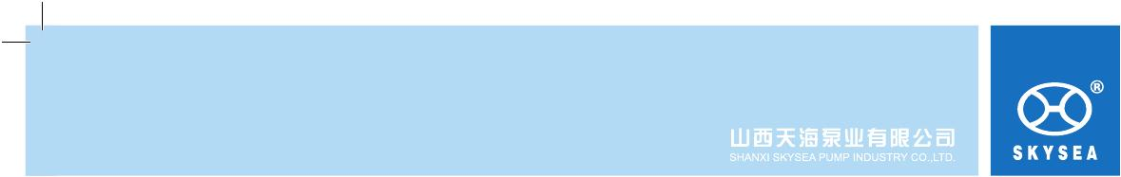
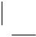

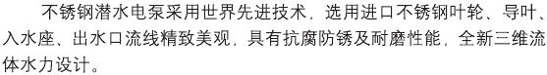
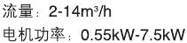
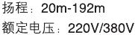
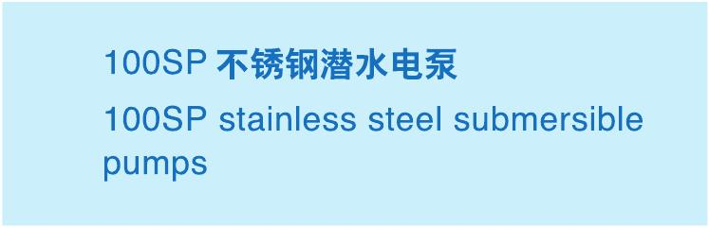

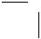
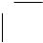

www.skyse a.com.c n
129

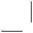
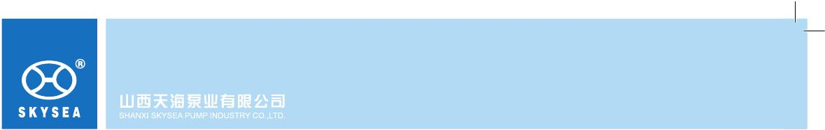
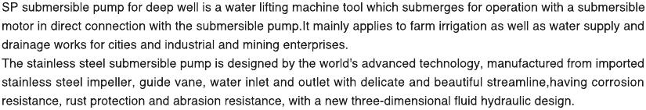
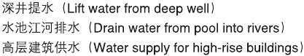
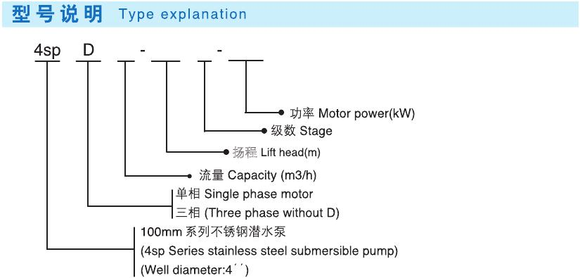
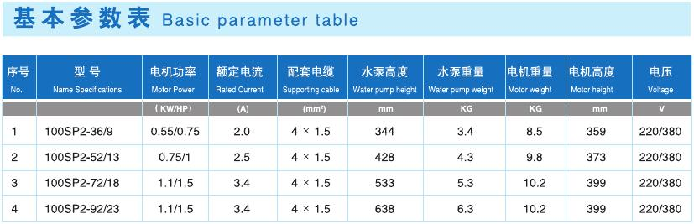


130

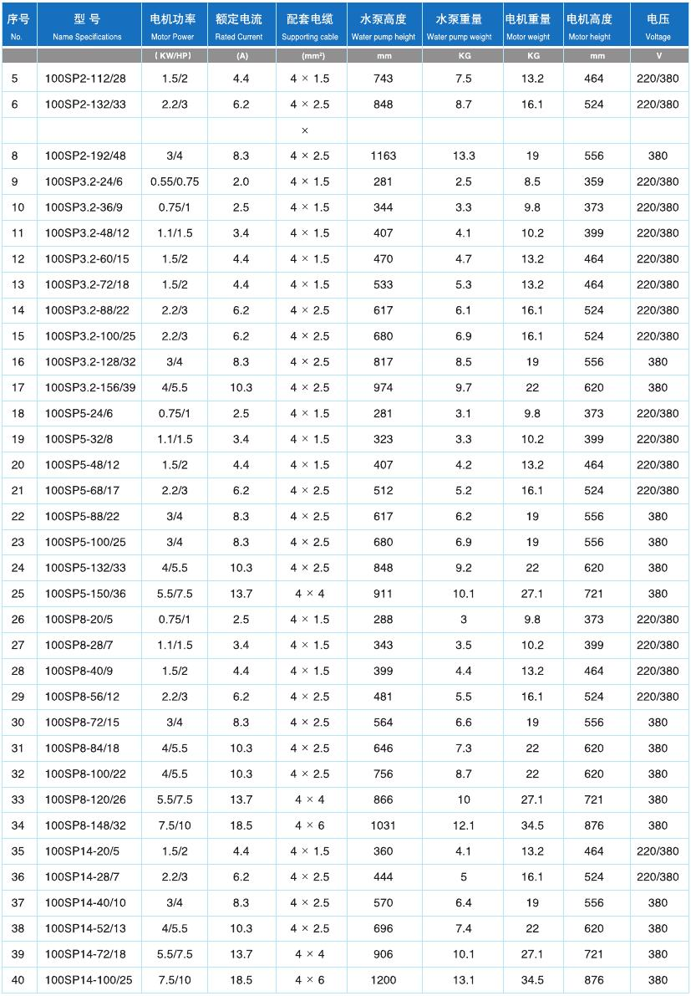

7
100SP2-160/39
2.2/3
6.2
4 2.5
995
9.8
16.1
524
220/380

以上额定电流为电机在电压 380V 时的额定电流。
The above rated current is the current of the motor that is working at 380V.

www.skyse a.com.c n
131

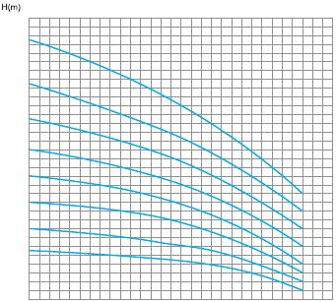
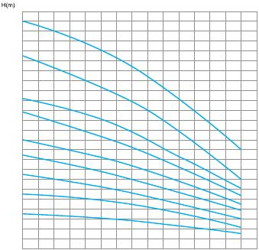
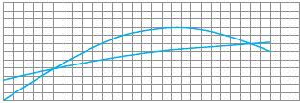
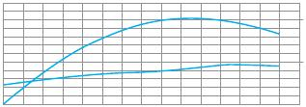
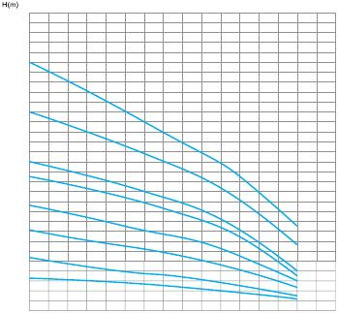
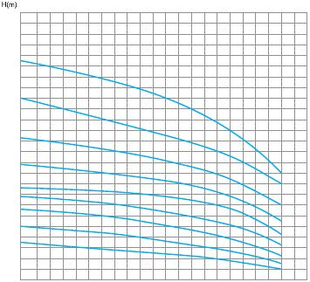
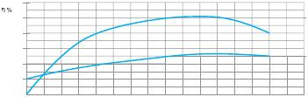
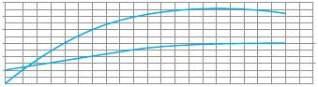

2
1
0
1
0
8
2

-1
10
100
0SP
6
-

3
/39

1
SP2
0

-1
0
S
2-

P
/32

1

00S
10
3

P2
32
S

1
P3.2
/2

-1

0SP2-
100SP
8

11
SP

10
22

3
-6
5

1
00S
2-9
P2-7
2/23
P3.2-

10
72/18

1
00S
2/18
P2-52/13
3.2

100
1
SP3
-60/15

100SP
2-36/9
100S
.2-
48/12

100S
P3.2-36/9
P3.2-24/6

0S
1
P5-
6

1
0/
P

10
1
0S
8-14
8/32

10
0SP
5-13
3

2
10
6
20

P8

10
-1

0S
00/25
00/22

0SP

8/22
1
SP5
1
P5
1
P5-6
10
P5
10
7
/12
/8
-24/6
P8-84/18
100
100
10

1
100SP8-72/15
8-56/12
0/9
8/7
100SP8-20/5

132

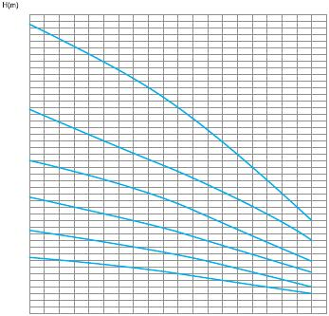
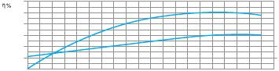
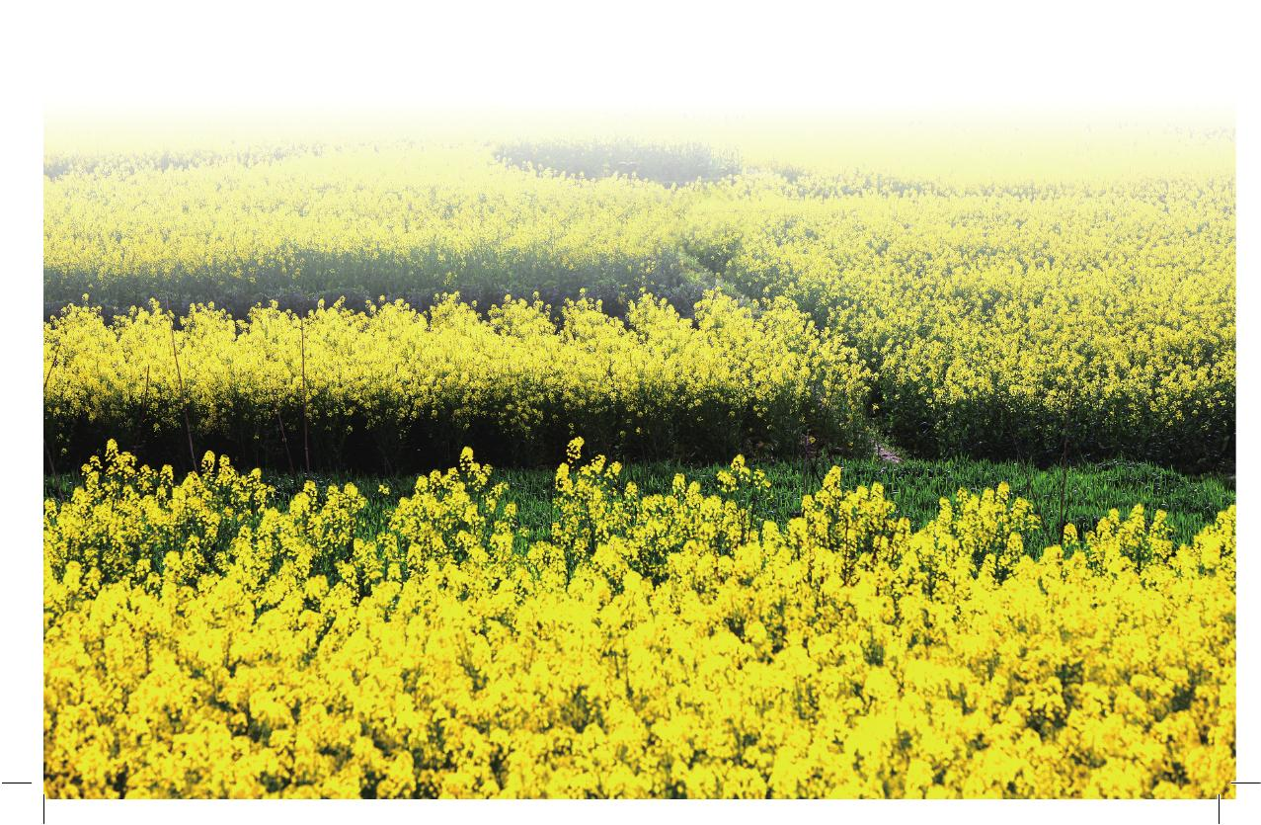

0S
1
/25
0
4

P

10
1
4
P

0
8
/

-

1
00S
00S
3
52

P1

100S
P14-
0

40

100
P14-2
8/7

/5
SP1

www.skyse a.com.c n
133

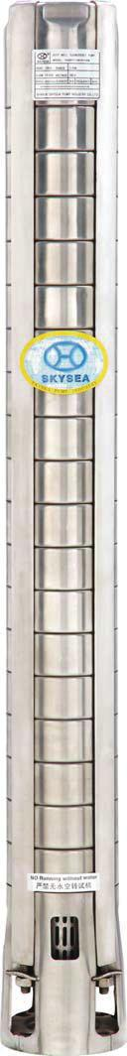
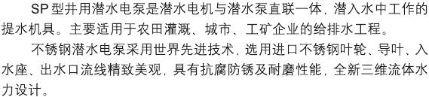
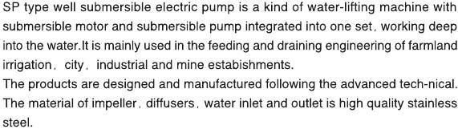
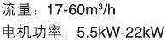
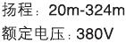
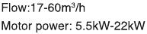
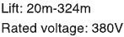
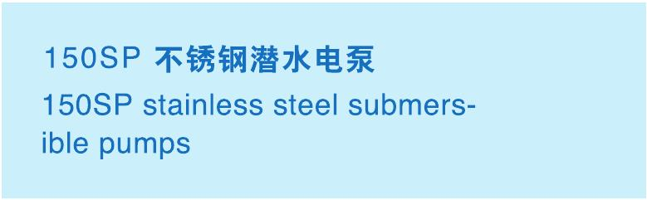

134

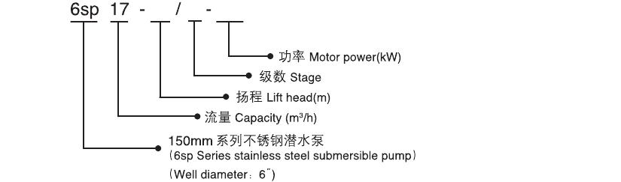
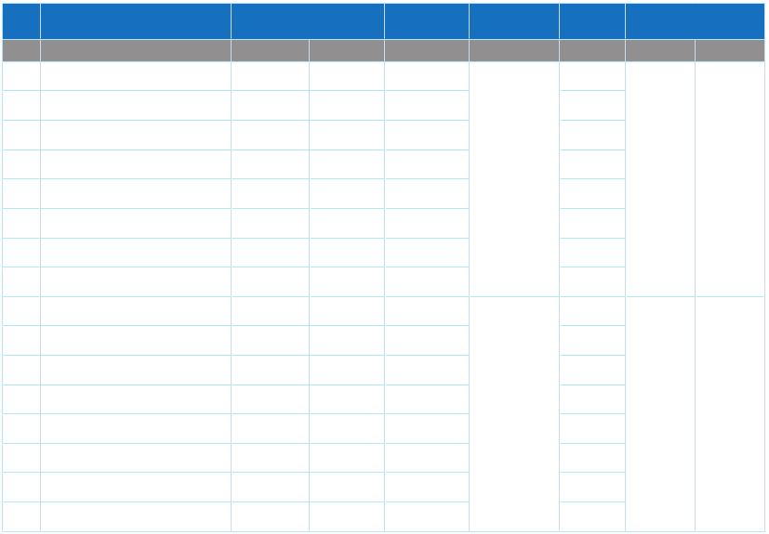

序号
No.
1
2
3
4
5
6
7
8
9
10
11
12
13
14
15
16
型号
Type
150SP17-74/9
150SP17-99/12
150SP17-124/15
150SP17-148/18
150SP17-173/21
150SP17-198/24
150SP17-247/30
150SP17-297/36
150SP30-39/5
150SP30-55/7
150SP30-71/9
150SP30-94/12
150SP30-110/14
150SP30-126/16
150SP30-150/19
150SP30-181/23
(kW)
5.5
7.5
9.2
11
13
15
18.5
22
5.5
7.5
9.2
11
13
15
18.5
22
功 率
Power
(HP)
7.5
10
12.5
15
17.5
20
25
30
7.5
7.5
12.5
15
17.5
20
25
30
高 度
Height
(mm)
675
810
945
1080
1215
1350
1620
1890
720
900
1080
1350
1530
1710
1980
2340
流 量
Flow
(m3/h)
17
30
扬 程
Head
(m)
74
99
124
148
173
198
247
297
39
55
71
94
110
126
150
181
出水管径
Outlet pipe diameter
(mm) (″)
65 2.5"
75 3"

www.skyse a.com.c n
135

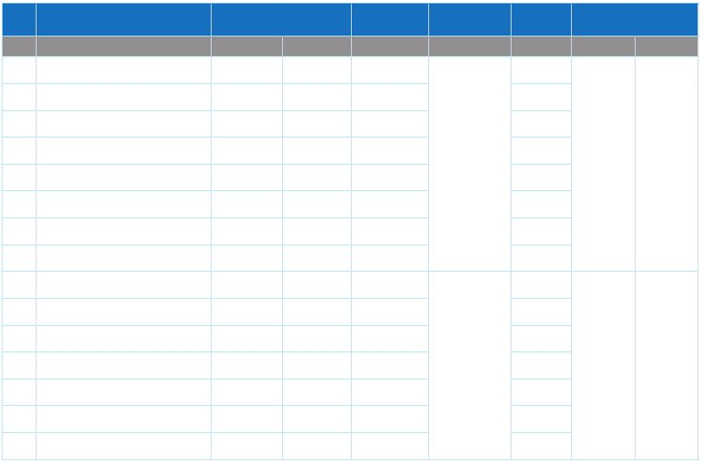
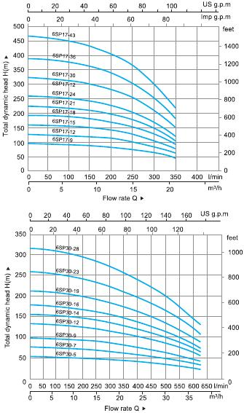
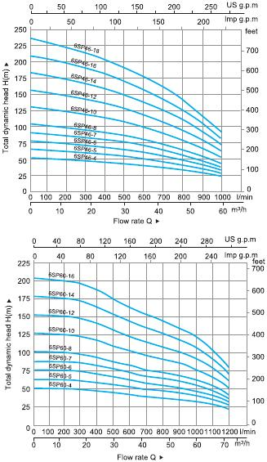

序号
No.
17
18
19
20
21
22
23
24
25
26
27
28
29
30
31
型号
Type
150SP46-35/4
150SP46-44/5
150SP46-53/6
150SP46-62/7
150SP46-70/8
150SP46-88/10
150SP46-106/12
150SP46-123/14
150SP60-31/4
150SP60-39/5
150SP60-46/6
150SP60-55/7
150SP60-62/8
150SP60-78/10
150SP60-94/12
(kW)
7.5
7.5
9.2
11
13
15
18.5
22
7.5
9.2
11
13
15
18.5
22
功 率
Power
(HP)
10
10
12.5
15
17.5
20
25
30
10
12.5
15
17.5
20
25
30
高 度
Height
(mm)
630
720
810
900
990
1170
1350
1530
670
770
870
970
1070
1270
1470
流 量
Flow
(m3/h)
46
60
扬 程
Head
(m)
35
44
53
62
70
88
106
123
31
39
46
55
62
78
94
出水管径
Outlet pipe diameter
(mm) (″)
75(100) 3"(4")
75(100) 3"(4")

136

